Since this program is an amplitude modulation,

ω = 2*pi*f0/RATE

θ = θ + ω

output_block[n] = int( input_tuple[n] * cos(θ) )

cosθ = ½(ejθ +e-jθ)

So H(ejw) = ½ H(ej(w-θ))+ ½H(ej(w+θ)), it is the sum of two signals which have shift compare to the origin. The shift distance is equal to f0.

The figures show clear change when input signal is whistle.

* When f0 = 400

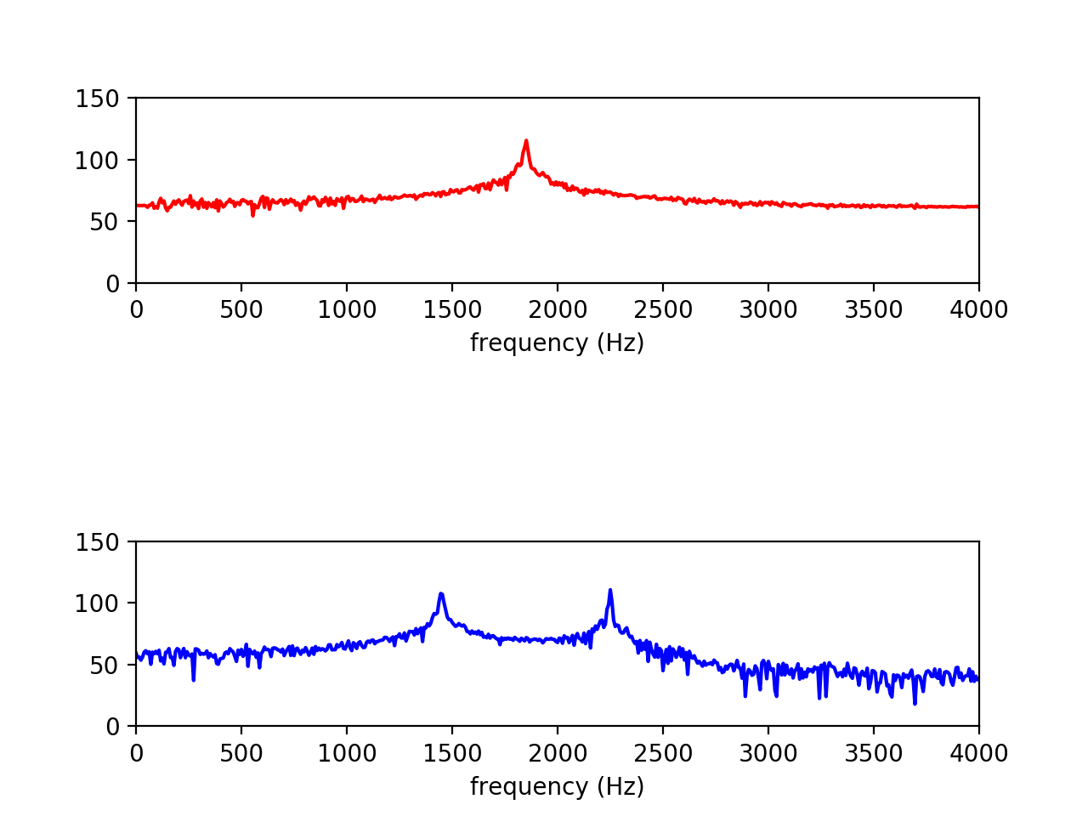

* When f0 = 200

